Types of inheritance in java

On the basis of class, there can be three types of inheritance in java: single, multilevel and hierarchical.

In java programming, multiple and hybrid inheritance is supported through interface only. We will learn about interfaces later.

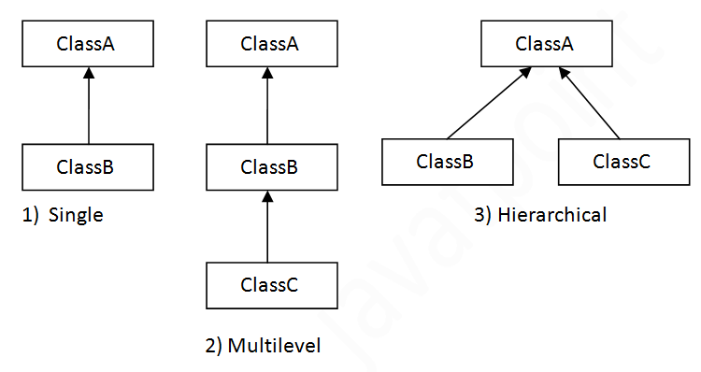

Note: Multiple inheritance is not supported in Java through class.

When one class inherits multiple classes, it is known as multiple inheritance. For Example:

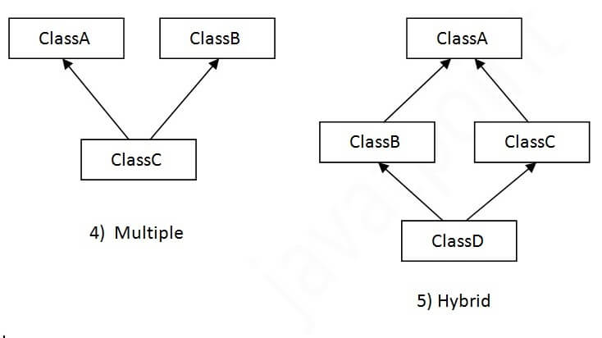

## Single Inheritance Example

When a class inherits another class, it is known as a single inheritance. In the example given below, Dog class inherits the Animal class, so there is the single inheritance.

## Multilevel Inheritance Example

When there is a chain of inheritance, it is known as multilevel inheritance. As you can see in the example given below, BabyDog class inherits the Dog class which again inherits the Animal class, so there is a multilevel inheritance.

## Hierarchical Inheritance Example

When two or more classes inherits a single class, it is known as hierarchical inheritance. In the example given below, Dog and Cat classes inherits the Animal class, so there is hierarchical inheritance.

## Q) Why multiple inheritance is not supported in java?

To reduce the complexity and simplify the language, multiple inheritance is not supported in java.

Consider a scenario where A, B, and C are three classes. The C class inherits A and B classes. If A and B classes have the same method and you call it from child class object, there will be ambiguity to call the method of A or B class.

Since compile-time errors are better than runtime errors, Java renders compile-time error if you inherit 2 classes. So whether you have same method or different, there will be compile time error.

## Aggregation in Java

If a class have an entity reference, it is known as Aggregation. Aggregation represents HAS-A relationship.

Consider a situation, Employee object contains many informations such as id, name, emailId etc. It contains one more object named address, which contains its own informations such as city, state, country, zipcode etc. as given below.

class Employee{

int id;

String name;

Address address;//Address is a class

...

}

In such case, Employee has an entity reference address, so relationship is Employee HAS-A address.

Why use Aggregation?

- For Code Reusability

### **When use Aggregation?**

* Code reuse is also best achieved by aggregation when there is no is-a relationship.
* Inheritance should be used only if the relationship is-a is maintained throughout the lifetime of the objects involved; otherwise, aggregation is the best choice.